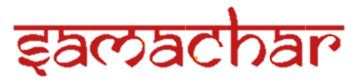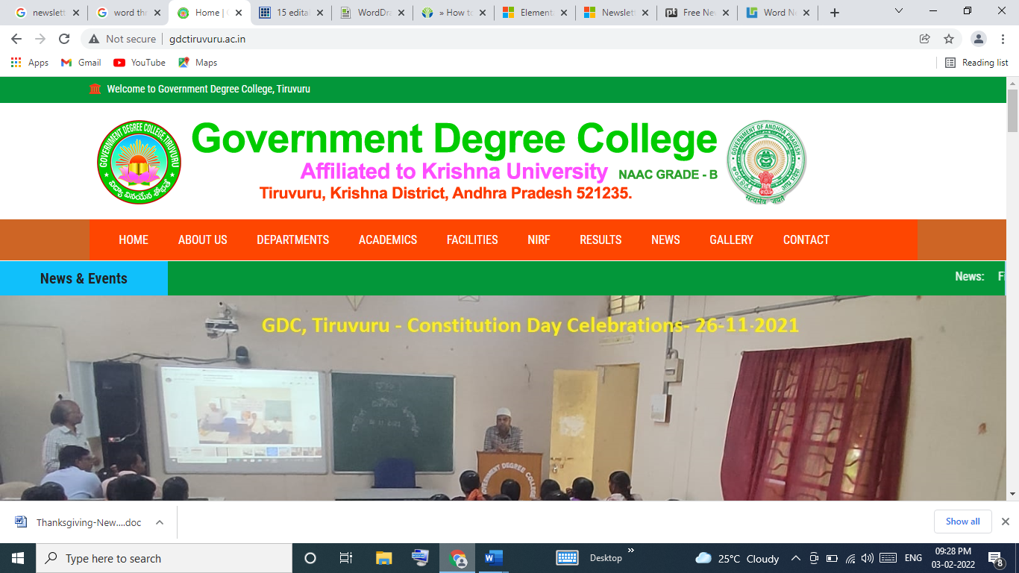

**Government Degree College, Tiruvuru, Krishna Dt – Monthly News Letter, March 2022**

Campus

Editorial Board

***Editor:***

Dr.M.Suseela Rao

Principal

***Co-Editor:***

Dr.Vijayananda Raju

Convener

World Poetry Day

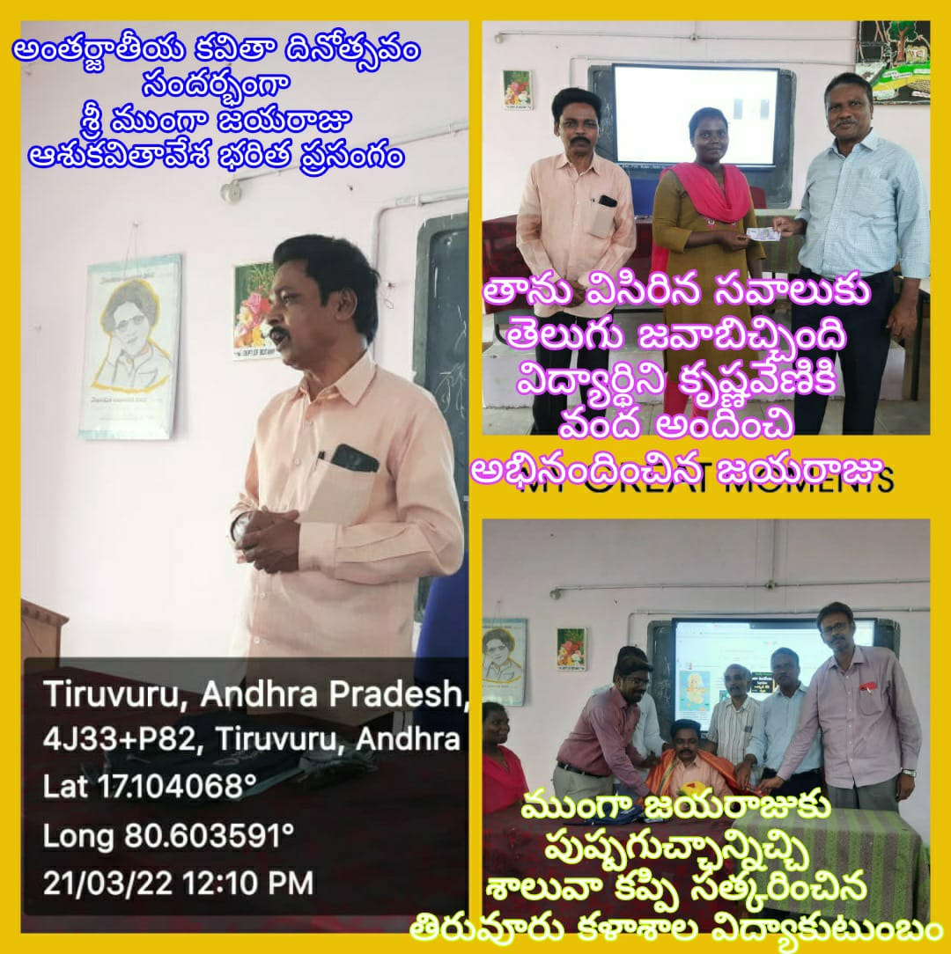

World Poetry Day is Organized by All the language departments on 21-03-2022.M.Jayaraju, Rtd Telugu Lecturer of this college was invited and he addressed the gathering (70 students). Delivering the speech on the greatness of the poetry , he recited some poems and verses spontaneously. He encouraged the students to read the poetry.

Martyr’s Day

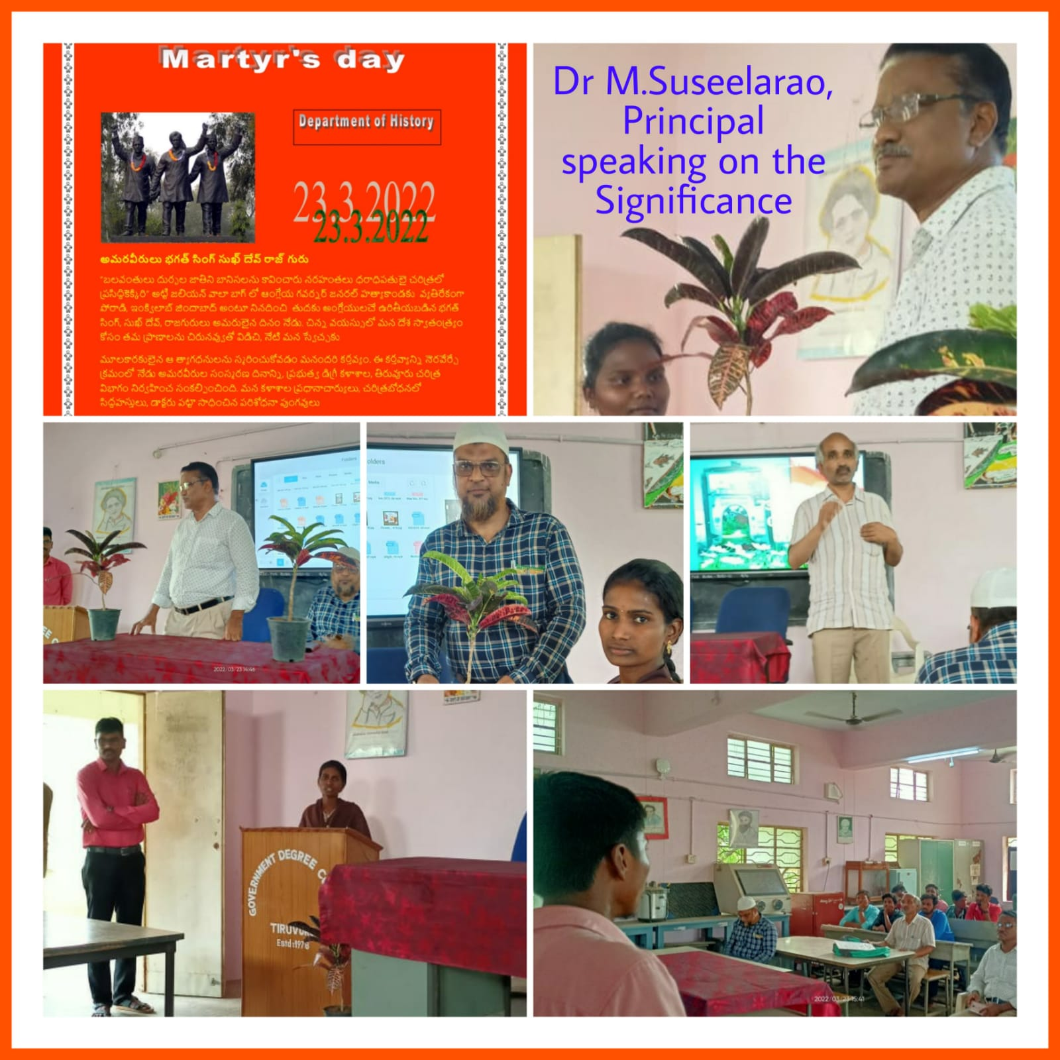

Martyr’s Day was observed on 23rd March 2022.

Commemorating the life sacrifice of Bhagat Singh, Rajguru and Sukhdev. On the occasion Dr.M.Suseela Rao, Principal of the college unfolded the significance of Martyr’s Day in connection with Jalian Wala Bagh incident. B.Chenna Reddy, Lecturer in History, had spoken about the patriotism of Indian freedom fighters. Vice Principal Syed Abubakar congratulated the History Department for having taken the initiative. All other departments along with the students had participated in the program.

NSS Special camp at Anjaneyapuram

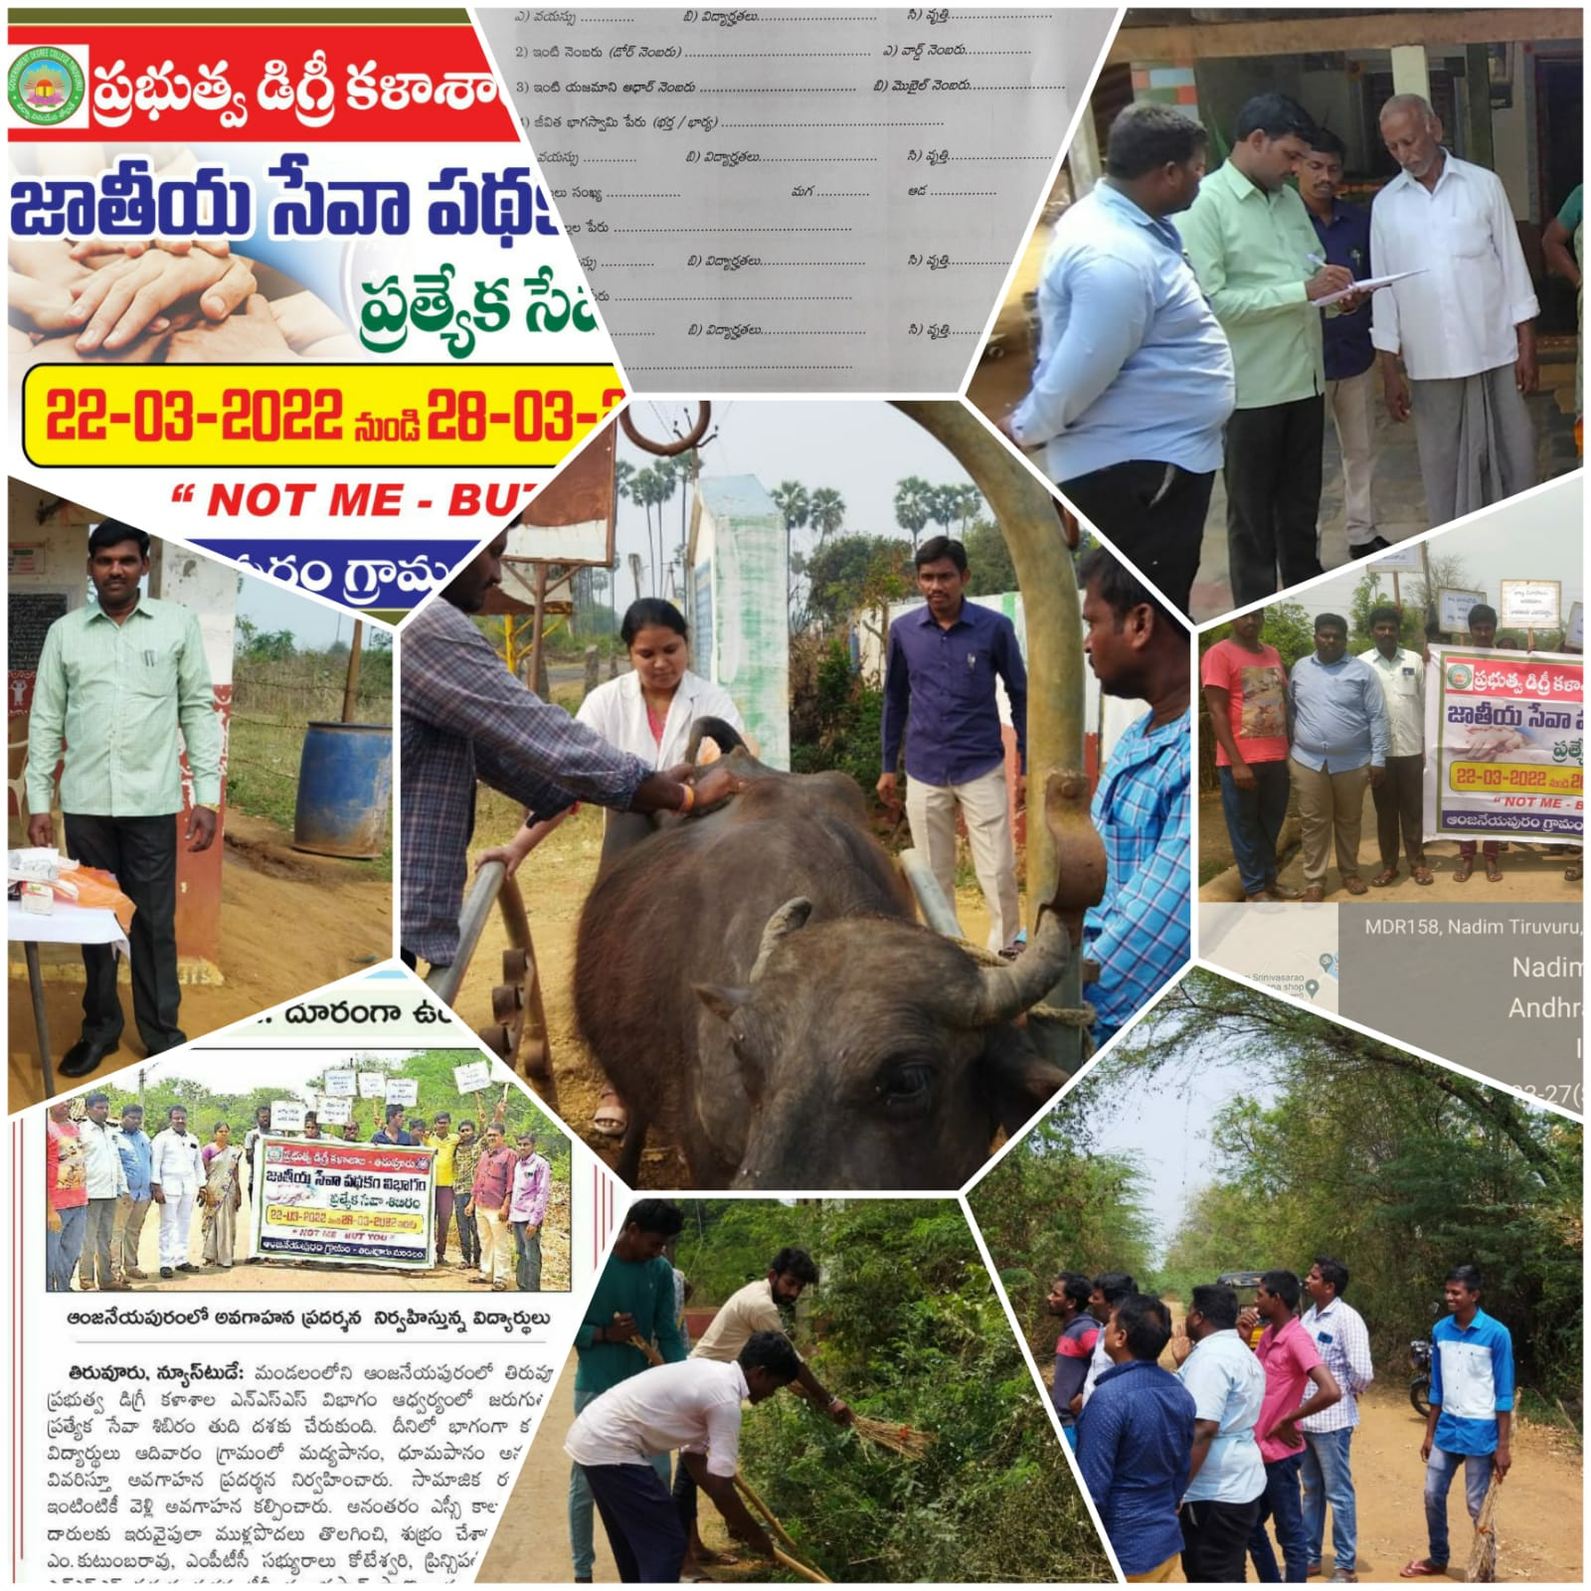

NSS Special camp was organized at Anjaneyapuram from 22-03-2022 to 29-03-2022. Free Veterinary Medical Camp was organized and medicines were distributed. Social survey, removing thorny bushes, held an awareness rally against the consumption of liquor, child marriages, and dowry system.

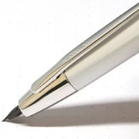

World Water Day

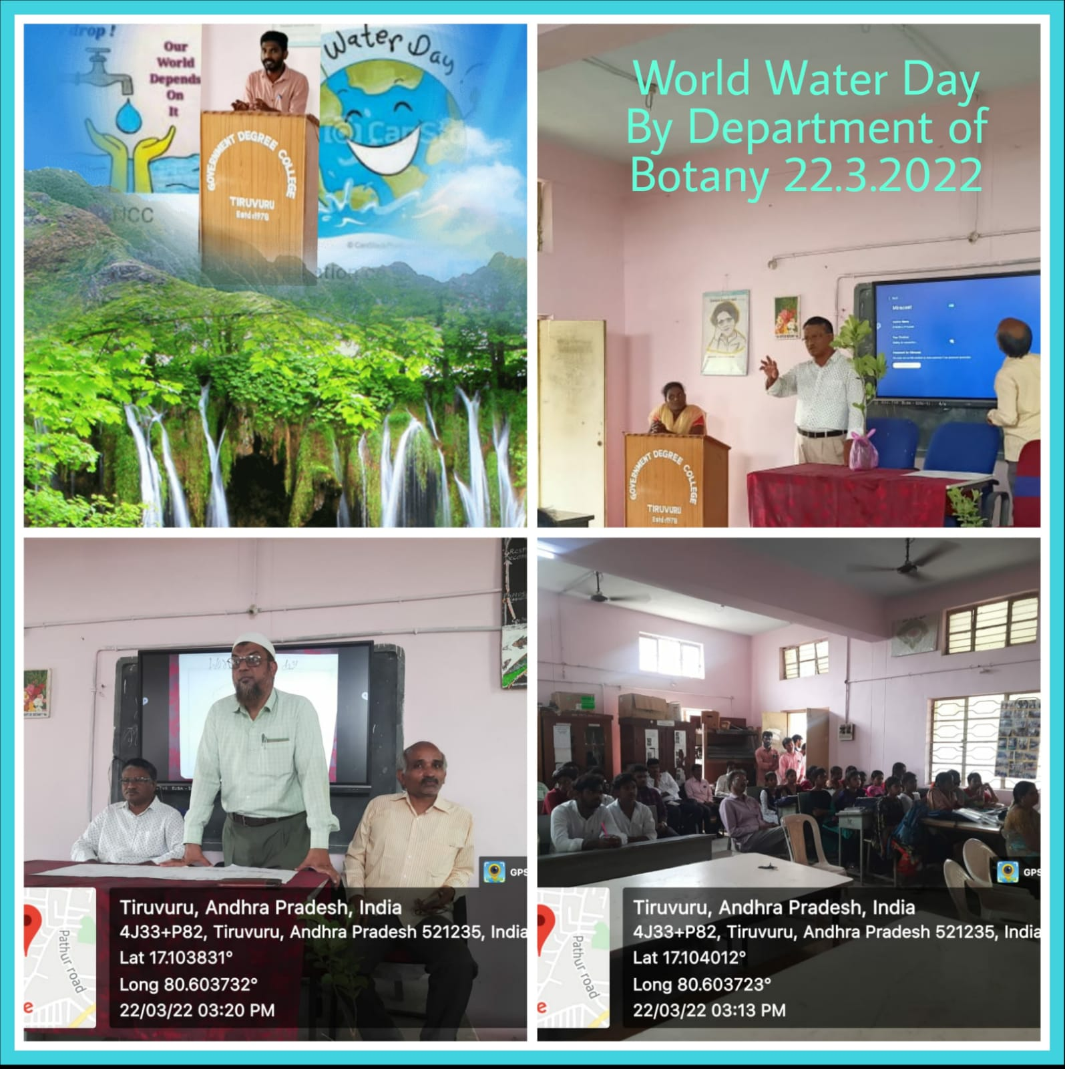

World Water Day is held on 22nd , March 2022. To focus on the importance of drinking water and conservation of natural resources as they are drying up day by day. Some videos signifying the importance of water to the living beings are shown on digital screen. All the speakers emphasized to use water judiciously and preserve it for future generations.



Campus

**Government Degree College, Tiruvuru, Krishna Dt – Monthly News Letter, March 2022**

**Page**

**2**

**Page**

**2**

Eco-Friendly Examination

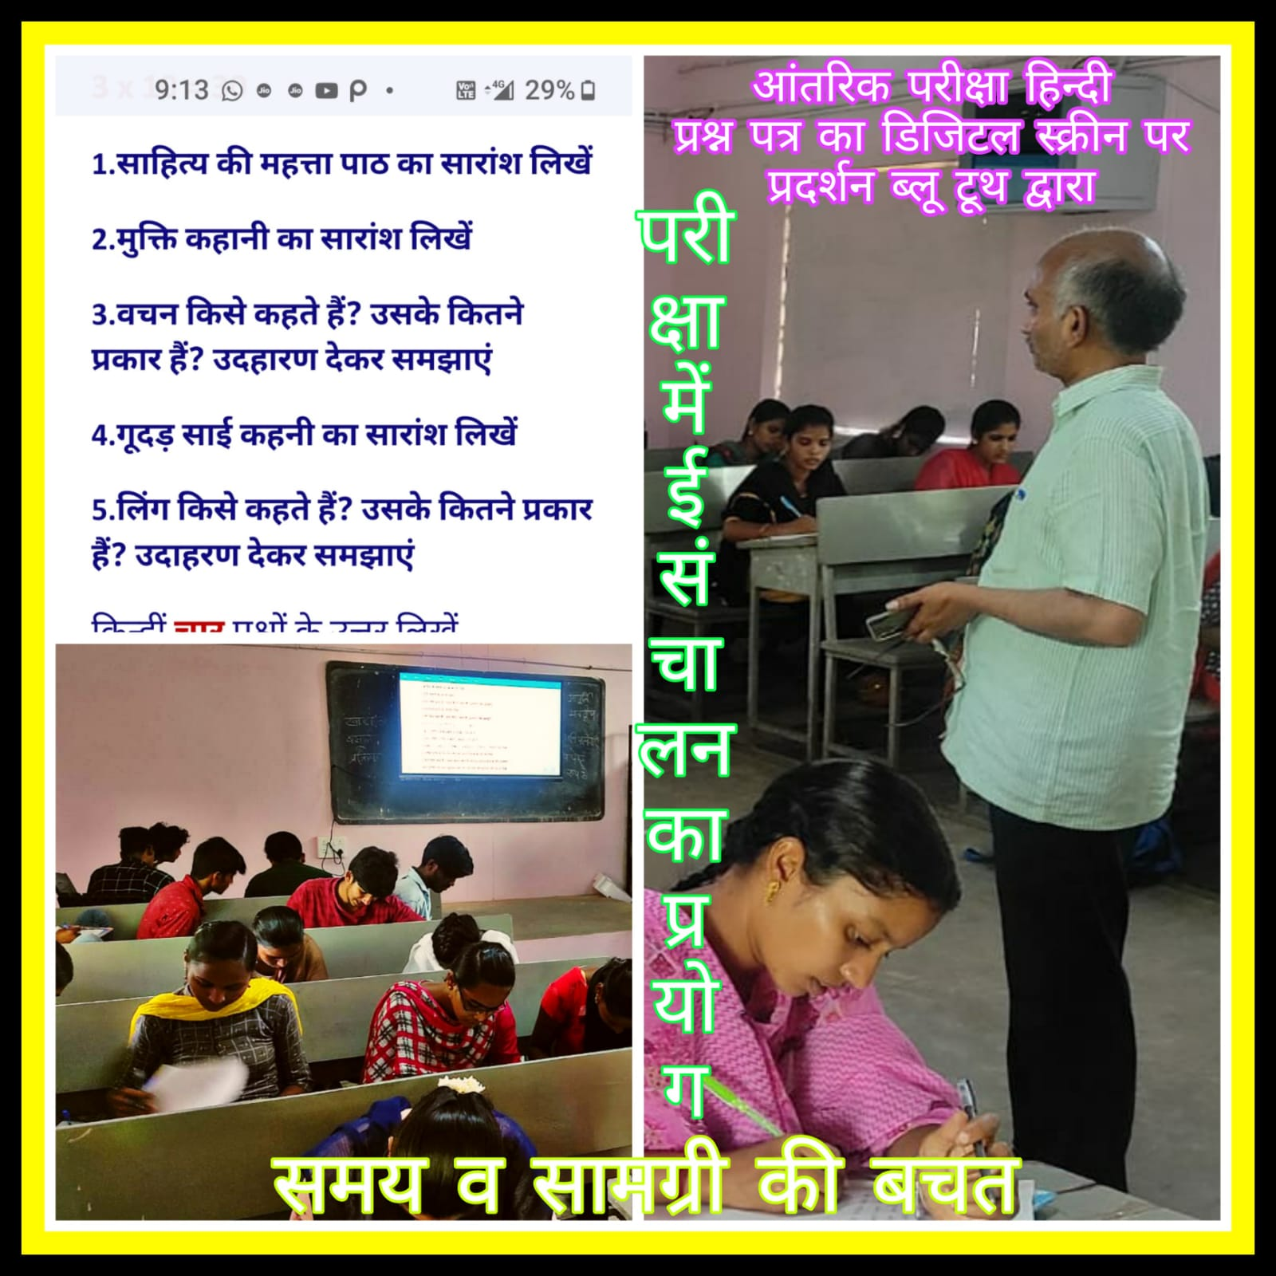

The Department of Hindi conducted mid-term examination on 30-03-2022 for 1 semester students on Digital Screen. This is unique in the sense that it saved lot of time and stationary (bio-friendly).

e-Governance in Internal Exams

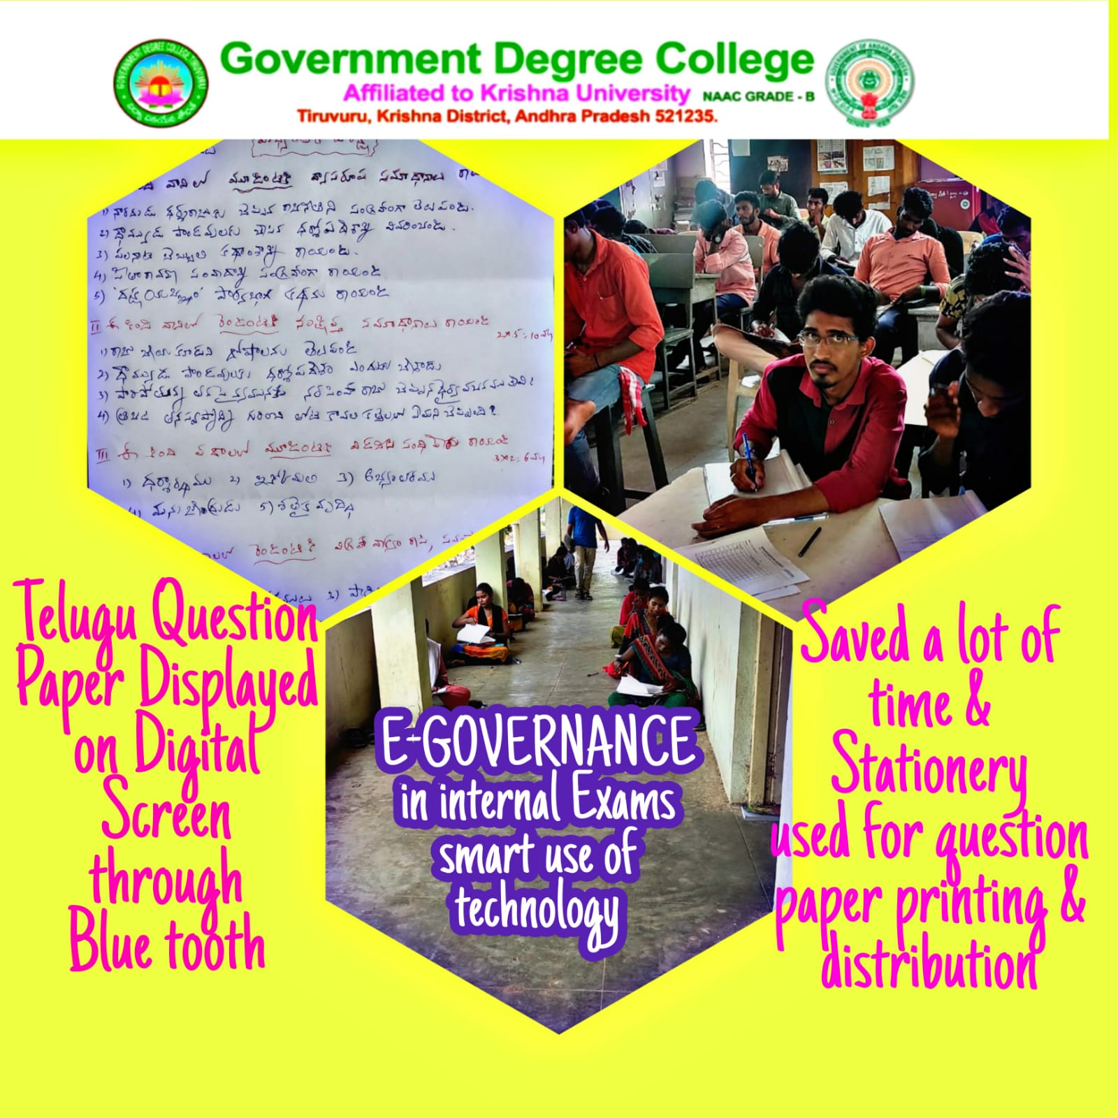

The Department of Telugu, has displayed Question Paper on digital screen through Bluetooth technology. Thus saved a lot of time and conducted the exam for around 140 students at a stretch. Pro Digital – Go Paperless- Do effortless.

Student Seminars

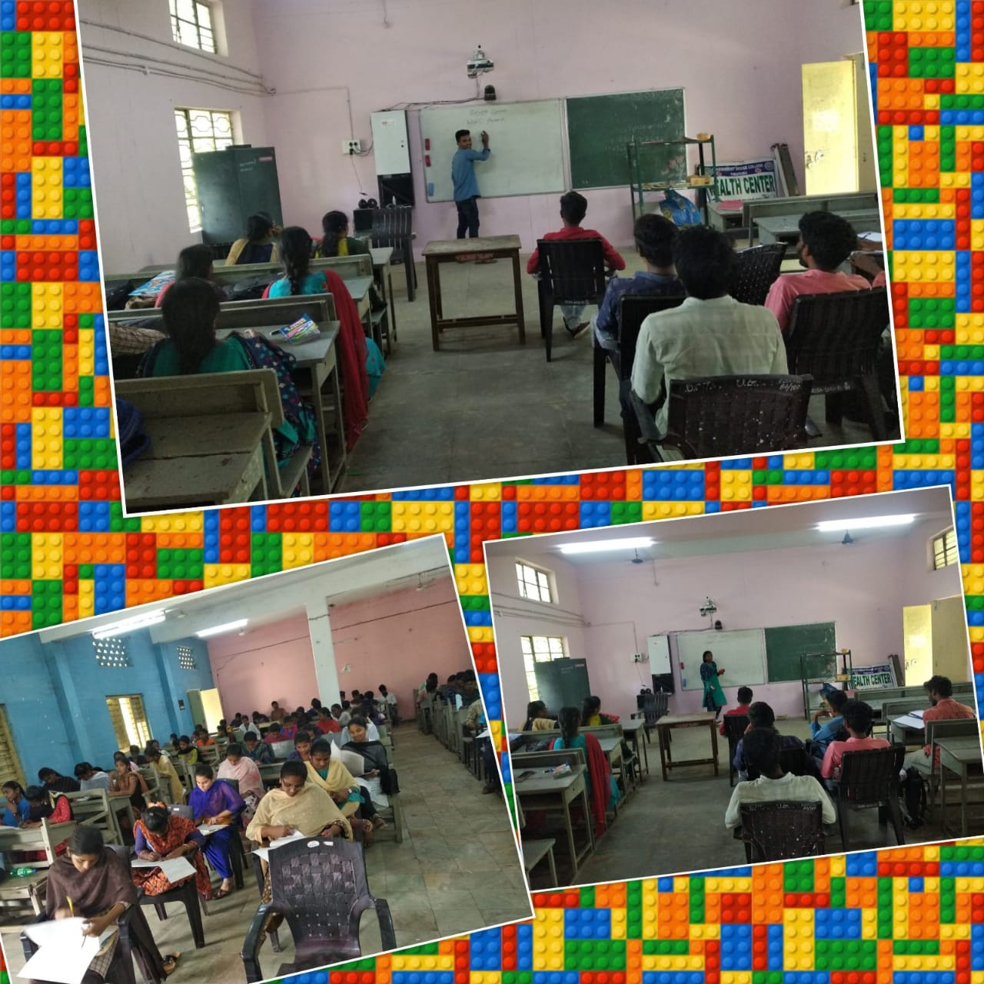

The department of English has conducted student seminars as part of Participative Learning on 31-03-2022.

Career Guidance

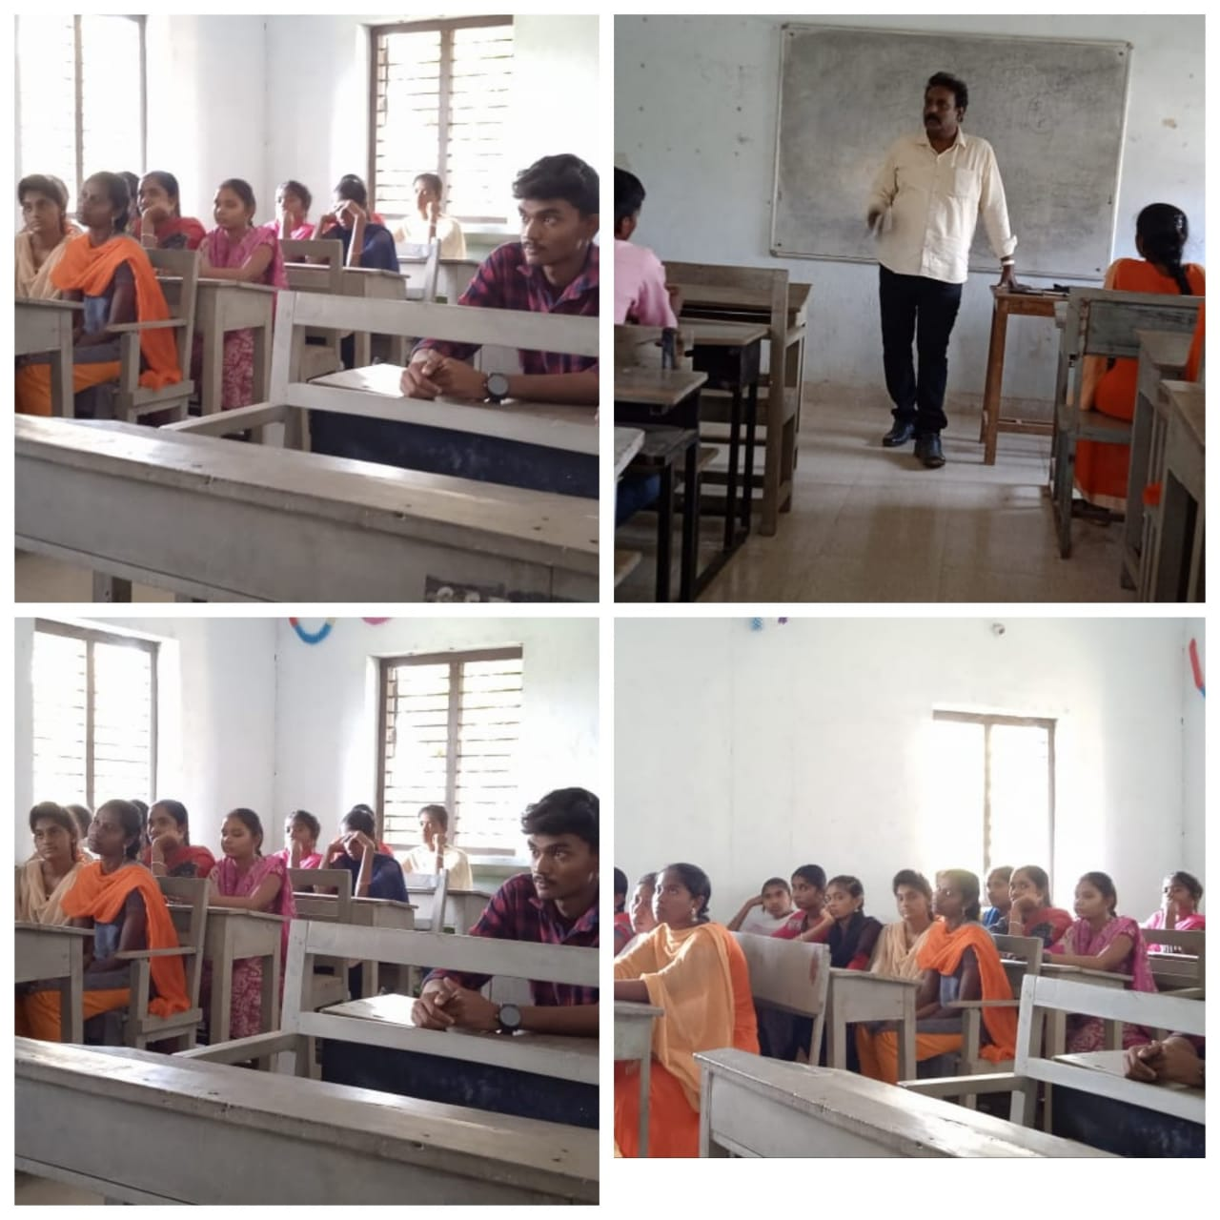

The Department of Arts has conducted a Career Guidance Program for final year students on 11-03-2022. The program focused on employment opportunities to the outgoing students in the cut-throat competition and skills required to make most of the opportunities. ***We Do – We Share – We Prosper.***

Skill Development Program

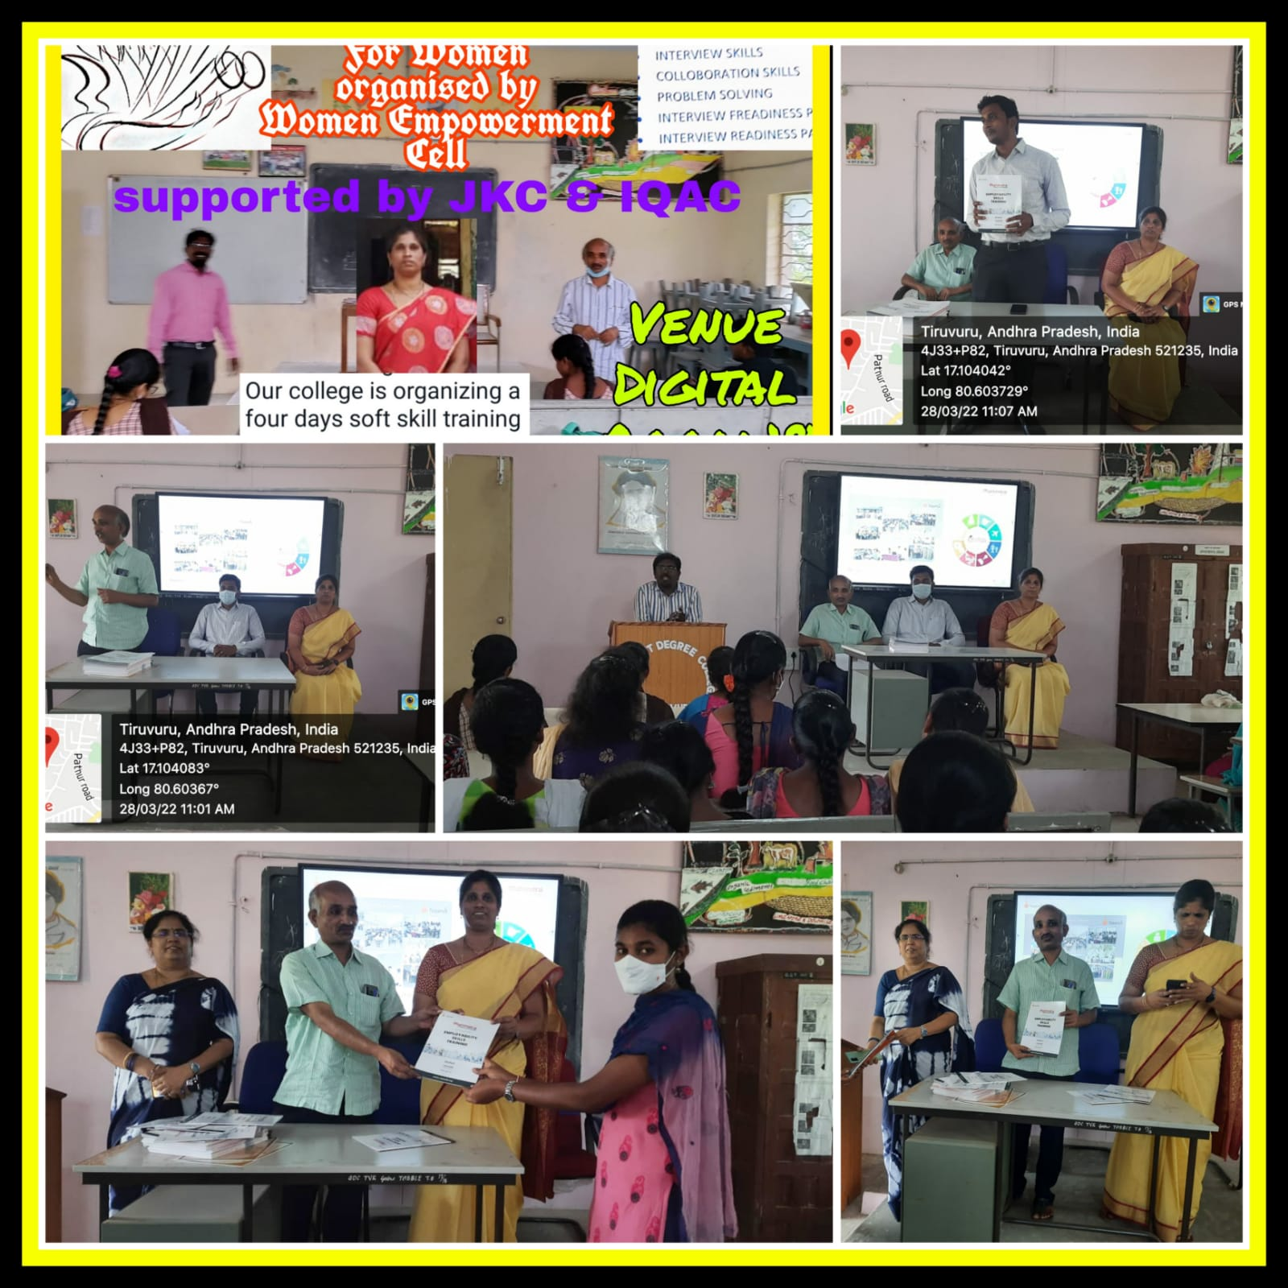

The Women Empowerment Cell of GDC, Tiruvuru in collaboration with Nandi Foundation has organized a two day training program for all the outgoing girl students on “Employability Skill Training Program” from 28-03-2022 to 29-03-2022. Certificates and study material is distributed to all the participants.

Guest Lecture

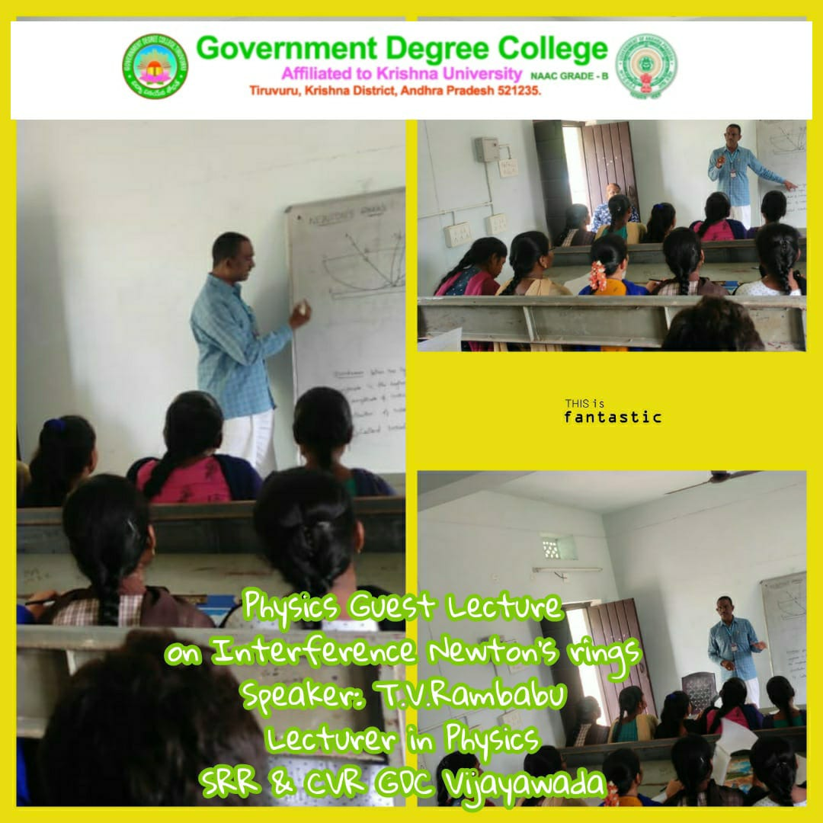

The Department of Physics has organized a Guest Lecture on “Interference Newton’s Rings” by TV Rambabu, SRR&CVR College,VJW.